ORTHOPAEDIC INSTRUMENTS
Instruments for Wires & Pins
K Wire Bender-Cutter-Plier 3-in-1
Intended Use
The K wire bender-cutter-plier 3-in-1 is a multi-function instrument used in veterinary orthopaedic surgery for Kirschner wire manipulation. In a single instrument, it bends K-wire ends to prevent migration, cuts wires to length, and grips wires for positioning during fracture fixation procedures in small and large animals. | 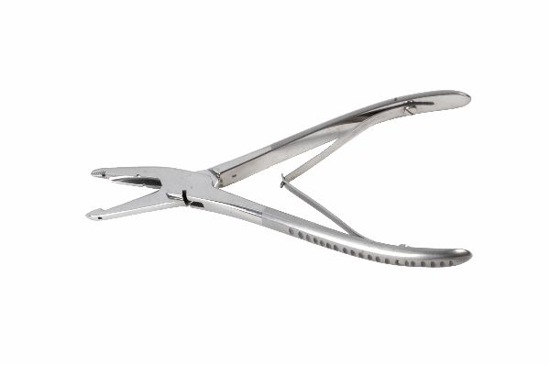
Function
Three functional zones are integrated into the jaws: a notched bending zone creates wire hooks and bends; sharp cutting edges in the mid-jaw shear K-wire stock; and a smooth-gripping plier zone handles wire during positioning. All three functions are accessible without changing instruments, maintaining sterile field efficiency.
Advantages
Three Functions, One Instrument: Consolidating bend, cut, and grip functions eliminates the need for three separate instruments on the sterile tray, reducing tray complexity and instrument processing time in high-volume small animal orthopaedic practices where multiple K-wires are used per case.
Sequential Task Efficiency: The surgeon can cut a wire to length, grip it for placement, and immediately bend the protruding end to prevent migration — all without releasing the instrument, maintaining continuous sterile field control and shortening the time between wire insertion and securing.
FAQ
Q: What K-wire diameter range does the 3-in-1 accommodate?
A: Most 3-in-1 instruments handle 1.0–2.5 mm K-wire diameters; always confirm the maximum cutting capacity before attempting to cut wires thicker than the instrument's rated capacity.
Q: Does cutting dull the bending and gripping functions?
A: Cutting work progressively wears the cutting edges without affecting the bending notch or grip faces; inspect cutting sharpness after every 10–15 cuts and have the cutting zone professionally resharpened when clean cuts are no longer produced.

ORTHOPAEDIC INSTRUMENTS
Instruments for Wires & Pins
K Wire Bender-Plier with Speed Lock
Intended Use
The K wire bender-plier with speed lock is used to bend Kirschner wire ends into hook or loop configurations that prevent wire migration after insertion in veterinary fracture fixation. The speed lock holds the bend without sustained hand pressure, allowing the surgeon to verify the result before releasing. | 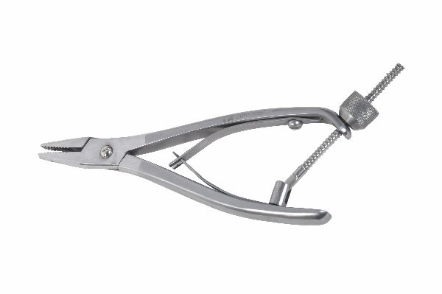
Function
Notched jaws grip the K-wire at the desired bend point. Closing the handles applies the bending moment while the speed lock ratchet maintains the handle position, holding the bend angle while the surgeon confirms wire position and bend geometry. Releasing the lock opens the jaws to reposition for additional bends.
Advantages
Held Bend for Inspection: The speed lock maintains the bend position after force application, allowing the surgeon to visually and tactilely confirm the wire hook geometry before releasing — preventing the gradual spring-back that can undo a bend when the instrument is released immediately.
Prevents Wire Migration: Properly bent K-wire ends form a mechanical stop against the periosteum or cortex that prevents proximal wire migration — a common complication of unbent wires in feline fracture cases where reduced activity does not protect against wire movement.
FAQ
Q: How much wire should protrude before bending?
A: Leave 1.0–1.5 cm of wire above the cortex entry point before bending; too little makes future extraction difficult, while too much creates a palpable and potentially painful subcutaneous prominence.
Q: What angle should K-wire ends be bent to?
A: A 90–120° bend parallel to the bone surface is standard for migration prevention; sharper bends are harder to extract, while shallower bends provide less anti-migration resistance.

ORTHOPAEDIC INSTRUMENTS
Instruments for Wires & Pins
K Wire Introducer
Intended Use
The K wire introducer is a hand-powered rotation instrument used to drive Kirschner wires into bone without power equipment. It provides controlled insertion of K-wires during fracture fixation, external skeletal fixation pin placement, and joint arthrodesis procedures in veterinary small animal surgery. | 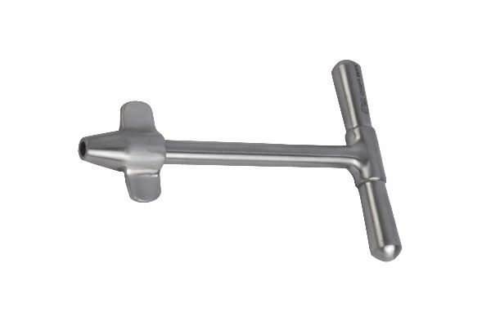
Function
The chuck mechanism grips the K-wire shank securely. The surgeon rotates the T-bar handle, transmitting rotation through the chuck into the wire tip, which cuts through cortex and cancellous bone as it advances. The T-handle provides tactile feedback on wire advancement and breakthrough.
Advantages
No Power Equipment Required: Hand-powered K-wire introduction is reliable in field surgery, after-hours emergency settings, and low-resource veterinary facilities where pneumatic or electric power sources may not be available or practical for a single K-wire placement.
Tactile Breakthrough Detection: The manual handle transmits the sudden resistance drop when the wire tip penetrates the far cortex, alerting the surgeon to stop advancing before the wire plunges beyond the intended depth and risks injuring adjacent soft tissue.
FAQ
Q: What wire sizes fit the K wire introducer chuck?
A: Most veterinary K wire introducers accommodate 0.8–2.5 mm diameter Kirschner wires; the chuck is tightened after wire insertion to prevent slip during rotation.
Q: Can the introducer be used to remove K-wires?
A: Yes — reversing the rotation direction backs the wire out of bone; the chuck grip holds the wire securely for controlled extraction when the wire does not have a hook end to grip with pliers.

ORTHOPAEDIC INSTRUMENTS
Instruments for Wires & Pins
Multi-Purpose Extractor-Plier with Vise Grip
Intended Use
The multi-purpose extractor-plier with vise grip is used to remove K-wires, Steinmann pins, cerclage wires and other small implants from bone after fracture healing in veterinary orthopaedic surgery. The vise grip locking mechanism maintains traction on the implant without sustained hand force during progressive extraction. | 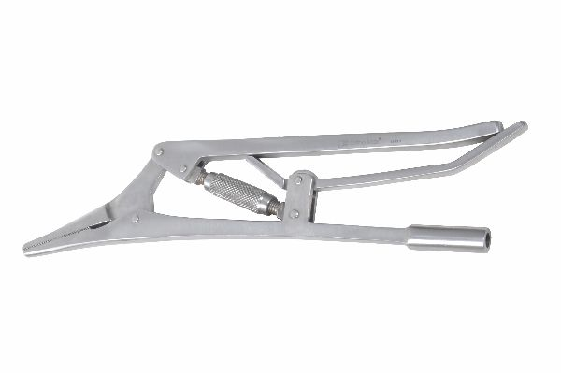
Function
Serrated vise-grip jaws clamp firmly onto the wire or pin end protruding above the cortex. The locking mechanism sets jaw pressure at a level that grips without slipping, then the surgeon applies steady pulling or rocking traction through the handle to withdraw the implant from the healed bone.
Advantages
Slip-Free Extraction Grip: The vise-grip mechanism prevents the instrument from sliding up the wire during extraction — a common failure with standard pliers that slip when high extraction force is needed for pins with significant bone ingrowth after extended implantation.
Frees Hands During Extraction: Once the vise grip is locked onto the implant, the surgeon can apply steady traction without maintaining grip pressure, allowing the non-dominant hand to stabilise the limb and prevent uncontrolled movement if the pin suddenly releases.
FAQ
Q: How are pins with no protruding end extracted?
A: The pin must be exposed by making a small skin incision and using a pin puller or small Hohmann elevator to lever the pin proximally to create a grip surface; the vise plier then grips the exposed end.
Q: Can this plier extract pins from cats with minimal protrusion?
A: A minimum of 3–5 mm of wire or pin must protrude above the cortex for effective vise grip purchase; less protrusion requires pin hook modification before extraction.

ORTHOPAEDIC INSTRUMENTS
Instruments for Wires & Pins
Watson Jones T Handle
Intended Use
Watson Jones' T handle is a manual rotation instrument used to rotate reamers, tap drills, intramedullary nails and K-wire introductory devices in veterinary orthopaedic procedures. Its T-bar profile provides the bimanual grip needed for controlled rotational force in confined access corridors. | [Missing: Watson Jone's 'T' Handle.jpg]
Function
A universal chuck or specific adaptor on the instrument accepts the shank of the reamer, tap or introducer. Both hands grip the T-bar ends and rotate in opposite push-pull motion to advance the instrument through bone. The handle length balances torque application against rotational control for each specific instrument diameter.
Advantages
Bimanual Torque Application: The T-bar allows both hands to contribute simultaneously to rotational force, achieving the consistent moderate torque needed for tapping and reaming without the wrist fatigue that single-handed rotation creates over extended drilling sequences.
Universal Adaptor Compatibility: A standard chuck interface accommodates diverse instrument shanks — tap handles, reamer drivers, wire introducers — making the Watson Jones T handle a universal rotation handle that serves multiple functions across the orthopaedic instrument set.
FAQ
Q: How is the T handle kept from walking off-axis during rotation?
A: Maintaining gentle axial pressure while rotating keeps the instrument tip centred in the hole; releasing axial pressure during rotation allows the instrument to wander off-axis, especially in tapered holes like cortical taps.
Q: Can the T handle be used with power attachment?
A: No — the T handle is purely manual. For power reaming, a dedicated power reamer driver is used; the T handle is specifically for situations where fine tactile control is prioritised over speed.

ORTHOPAEDIC INSTRUMENTS
Instruments for Wires & Pins
Wire Passer Fibre Handle
Intended Use
The wire passer with fibre handle is used to thread cerclage wire around long bones and through tissue planes during fracture fixation procedures in veterinary orthopaedics. It navigates the wire safely around the bone circumference without injuring the periosteal blood supply or adjacent neurovascular structures. | 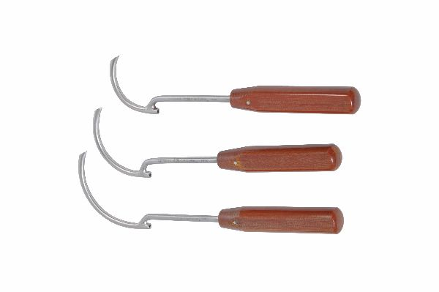
Function
A curved, smooth-tipped eyed needle at the distal end is loaded with the cerclage wire and passed around the bone through a subperiosteal or parosseous route. The fibre handle provides insulated grip and ergonomic control as the curved tip navigates the wire around the bone geometry without direct tactile vision.
Advantages
Subperiosteal Wire Passage: The smooth curved tip allows subperiosteal passage of cerclage wire around the bone without stripping more periosteum than necessary, preserving the periosteal blood supply that is critical for endosteal callus formation in cerclage wire fixation cases.
Prevents Instrument Thermal Issues: The fibre (non-metallic) handle prevents heat conduction to the surgeon's hand during autoclaving inspection and intraoperative use, and eliminates any galvanic interaction with metallic implants in the surgical field.
FAQ
Q: What cerclage wire gauge does this passer accommodate?
A: Most wire passers accommodate 0.8–1.2 mm cerclage wire, the standard range for cerclage fixation in canine diaphyseal fractures; larger wire requires a broader-eyed passer or a loop technique.
Q: When is cerclage wire indicated alongside plate fixation?
A: Cerclage wire is used to reduce and temporarily hold long oblique fracture fragments before plate application; after plating, the wire remains as supplementary circumferential support but must not be used alone as the primary fixation.

ORTHOPAEDIC INSTRUMENTS
Instruments for Wires & Pins
Wire Tightener with Two Pegs
Intended Use
The wire tightener with two pegs is used to tension and tighten cerclage wire, tension band wire, and figure-of-eight wire configurations in veterinary fracture fixation to the precise tension required for stable fracture compression. The two-peg design provides a secure, reproducible tightening technique. | 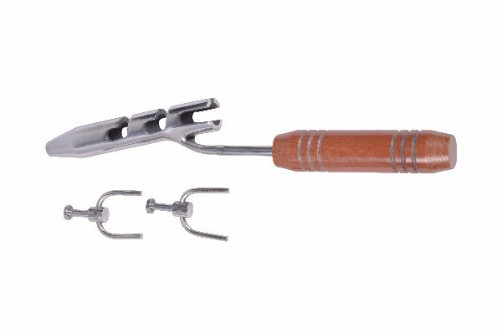
Function
The two pegs engage different strands of the wire twist. As the handle is rotated, the pegs wind the wire ends together, progressively increasing tension. The surgeon monitors tension by palpation and stops tightening at the point where the wire is taut against the bone without over-tensioning that would break the wire.
Advantages
Controlled Tension Development: The peg-and-rotate mechanism develops wire tension gradually and uniformly, preventing the sudden over-tension that can snap 0.8–1.0 mm cerclage wire when using plier twisting — a particularly important control feature in the thin cerclage wires used in feline fracture cases.
Clean Twist Formation: Two-peg engagement produces a tight, even twisted knot with uniform strand spacing, avoiding the loosely wound twists that standard pliers create which subsequently loosen under cyclical load and allow cerclage migration.
FAQ
Q: How tight should cerclage wire be tensioned?
A: The wire should be taut enough that it cannot be moved laterally along the bone surface with moderate thumb pressure, but not so tight that it cuts through the periosteum — approximately 50–80 N tension for standard cerclage wire sizes.
Q: Where should wire twist ends be positioned?
A: Twist ends should be cut short (3–5 mm), folded flat against the bone, and positioned away from neurovascular structures; exposed sharp twist ends cause soft tissue irritation and can be palpated as a subcutaneous prominence.

ORTHOPAEDIC INSTRUMENTS
Instruments for Wires & Pins
Wire Twister – Pencil Type
Intended Use
The pencil-type wire twister is a compact, single-hand wire tensioning instrument used to tighten individual cerclage wire loops around bone or create figure-of-eight tension band wire knots in veterinary fracture and orthopaedic surgery. Its slim pencil-grip profile provides precision in confined spaces. | 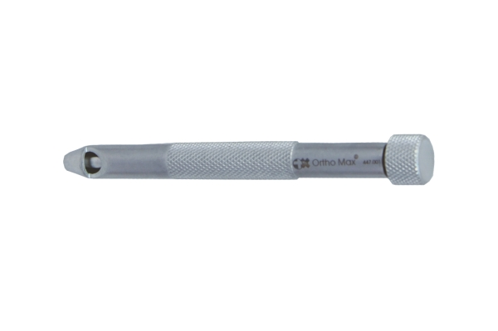
Function
The slim handle is rotated between the thumb and fingers like a pencil, winding the wire ends together through the eye at the instrument tip. The compact tip fits into tight access corridors where standard wire twisters cannot be manoeuvred, and the pencil grip allows finer rotational control for small-gauge wires.
Advantages
Confined-Space Access: The pencil-slim profile of this twister accesses wire locations behind and around bones in deep wounds where standard plier-style twisters are too bulky, enabling proper wire tensioning in stifle tension band fixation and spinal fracture cerclage cases.
Fine Wire Gauge Compatibility: The precision pencil rotation is appropriate for 0.8–1.0 mm cerclage and tension band wires in feline and small breed patients where the coarser motion of plier-type twisters over-tensions and breaks fine wire gauges.
FAQ
Q: How many rotations are needed to achieve adequate wire tension?
A: Typically 5–8 rotations from the point of initial wire loop closure are needed; the wire becomes noticeably stiffer to rotate at adequate tension, providing tactile feedback to prevent over-tightening.
Q: Is the pencil twister also used for figure-of-eight wire?
A: Yes — the tip engages the cross-over point of figure-of-eight wires for tension band fixation of patellar fractures, olecranon avulsions, and similar tension band applications in small animal patients.

ORTHOPAEDIC INSTRUMENTS
Instruments for Wires & Pins
Wire Twister
Intended Use
The standard wire twister is a robust instrument used to apply and tension cerclage wire in veterinary orthopaedic fracture repair. Its T-handle or palm-grip design provides the rotational force and control needed for reliable wire tensioning in medium and large breed canine fracture fixation procedures. | 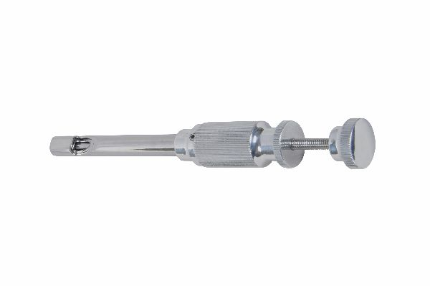
Function
The wire ends are threaded through the twister tip. Rotating the handle winds the wire ends into a tight twist, progressively increasing tension. The instrument body provides sufficient mechanical advantage for adequate tensioning of 1.0–1.5 mm cerclage wire in large breed patients where significant tension force is required.
Advantages
High-Tension Capability: The T-handle or palm-grip design delivers the torque force needed to adequately tension 1.2–1.5 mm cerclage wire in large breed dogs where pencil-type twisters lack the mechanical advantage for sufficient wire tension.
Durable All-Steel Construction: Fully stainless steel construction withstands the high torque applied during large-dog cerclage tensioning without handle deformation, maintaining accurate tip engagement with wire strands through repeated high-force tightening sequences.
FAQ
Q: When is the standard twister used versus the pencil type?
A: Use the standard twister for 1.0–1.5 mm cerclage wire in medium and large breeds requiring higher tension; use the pencil type for fine 0.8 mm wire in cats and small breeds where lower tension is appropriate.
Q: How are twisted wire ends finished after tensioning?
A: Cut the twist 3–5 mm above the wire loop, fold the cut end flat against the bone with pliers, and ensure the folded end points away from nearby vessels and nerves to prevent soft tissue erosion.

ORTHOPAEDIC INSTRUMENTS
Instruments for Wires & Pins
T Handle for Schanz Screw
Intended Use
The T handle for Schanz screw is used to manually drive Schanz screws into bone during external skeletal fixator (ESF) pin placement in veterinary orthopaedic surgery. It provides the manual rotation needed to advance self-tapping Schanz screws through cortical bone when power drill access is limited or when fine tactile control is preferred. | [Missing: 'T' Handle for Schanz Screw.jpg]
Function
The T handle chuck grips the Schanz screw's hex or smooth shank. The surgeon applies downward axial pressure while rotating the T-bar, advancing the screw's self-tapping tip through the near cortex, medullary canal, and far cortex. Tactile feedback through the handle signals the screw's bicortical engagement.
Advantages
Tactile Cortical Feedback: Manual T-handle insertion allows the surgeon to feel the resistance change when the screw tip engages the far cortex, preventing excessive advancement beyond the bone that risks periosteal stripping and injury to structures adjacent to the far cortex.
Essential Emergency Backup: When pneumatic or electric drills fail or are unavailable in emergency fracture scenarios, the T-handle provides reliable Schanz screw placement capability, ensuring ESF can be applied without dependency on powered equipment.
FAQ
Q: What torque is appropriate for Schanz screw insertion by T-handle?
A: Schanz screws are advanced until bicortical purchase is confirmed by resistance increase through the far cortex; the screw should not be over-advanced or loosened by over-rotation which strips the screw threads in the cortex.
Q: Can the T-handle be used with 2.7 mm and larger Schanz screws?
A: Yes, but larger diameter Schanz screws in dense cortical bone require a power drill for reliable insertion; the T-handle is most practical for 2.0–2.7 mm pins in accessible bone locations.

ORTHOPAEDIC INSTRUMENTS
Instruments for Wires & Pins
T Handle with S.S. Chuck & Key
Intended Use
The T handle with stainless steel chuck and key is a precision manual rotation instrument used to drive K-wires, small pins, tap drills, and other shank-mounted instruments in veterinary orthopaedic procedures. The keyed chuck provides secure, fully tightened grip that prevents slippage under rotational load. | [Missing: 'T' Handle with S. S. Chuck & Key.jpg]
Function
The three-jaw chuck is tightened with the included chuck key, clamping the instrument shank securely regardless of diameter within the chuck range. The T-bar is then rotated bimanually to advance the instrument through bone, with the rigid chuck-to-shank interface ensuring all rotational energy transfers to the working tip without slip.
Advantages
Slip-Free Chuck Engagement: The keyed three-jaw chuck tightens concentrically around the shank, eliminating the slip that occurs with keyless chucks when rotational resistance suddenly increases — slip is especially problematic when tap drills encounter dense cortical bone mid-rotation.
Wide Shank Diameter Range: The adjustable three-jaw design accommodates shank diameters from 1.0 mm to 6.0 mm, giving the T-handle versatility across K-wires, large pins, reamer shafts, and tap handles within a single instrument.
FAQ
Q: How tight should the chuck be tightened with the key?
A: Tighten until the chuck key clicks or the jaws no longer advance — do not overtighten, which can bow the chuck jaws and cause eccentric gripping that makes the instrument run off-axis during rotation.
Q: What is the advantage of an SS chuck over a standard steel chuck?
A: Stainless steel chuck components resist the corrosion that develops in standard carbon steel chucks from repeated steam sterilisation cycles, maintaining the smooth jaw movement and concentric closure needed for accurate gripping.

